Glogster Tutorial

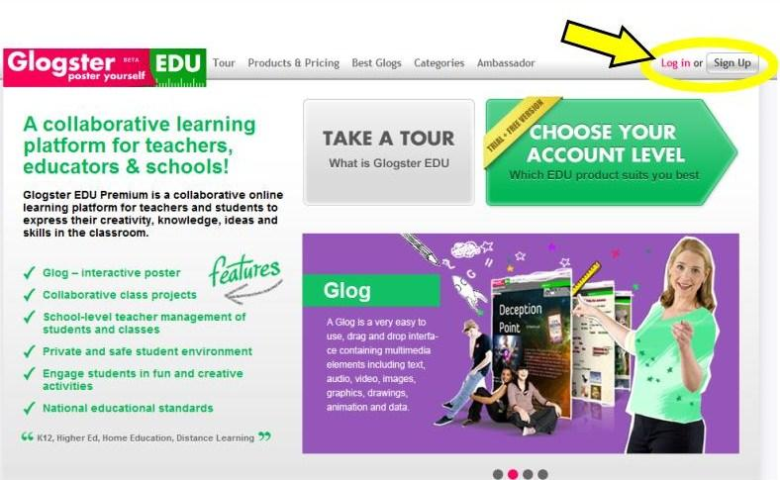  1. Visit edu.glogster.com. Click on Sign Up at the top right corner of the page. If you already have a Glogster EDU account, Log In. | 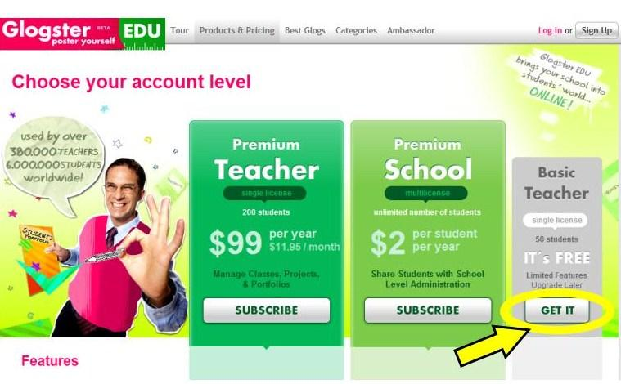  2. Choose which account you want to register for. For the FREE Basic account, click GET IT.
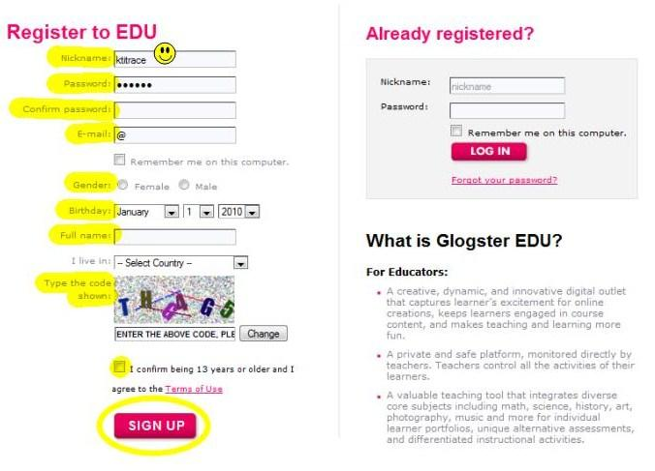  3. Fill in all of your information. Click SIGN UP. | 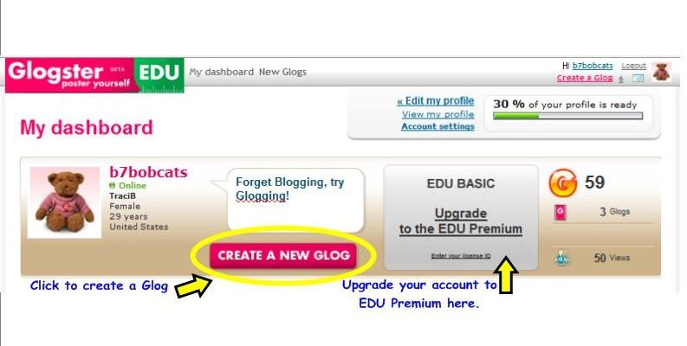  ]  4. You will see your Dashboard. This is the page where you can edit your profile, account settings, upgrade to EDU Premium... or most importantly, CREATE A GLOG!

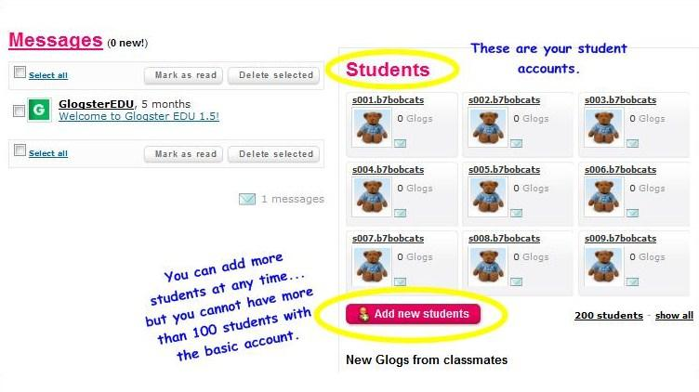  5. When you scroll down the page, you will see your Students. You can add new students at any  time (up to 100 with Basic Account). | 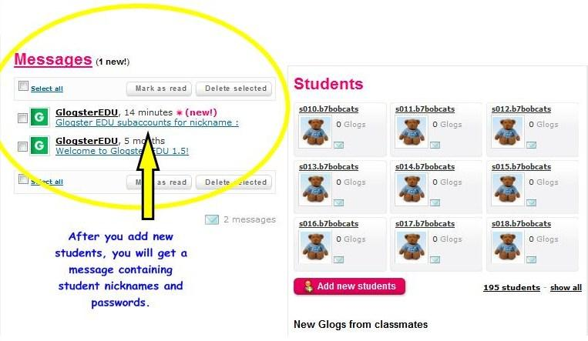  6. This is where your message will appear with your student account information.
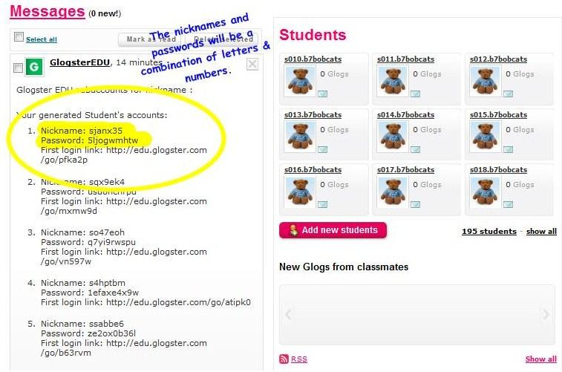  7. The student nicknames and passwords will be a letter/number combination. This is the nickname your student will log in as. You are able to change  the password. | 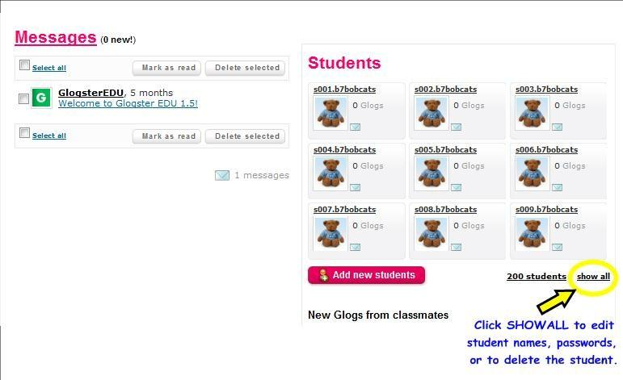  8. If you click on SHOW ALL, you can edit student names, passwords, or delete students.
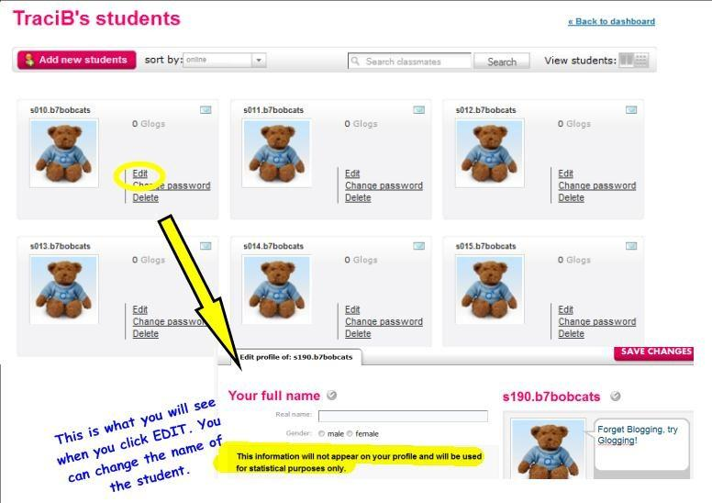  9. Click on EDIT to change the full name of the student. This information will not appear on the student's profile page, it is for statistical purpose only. | 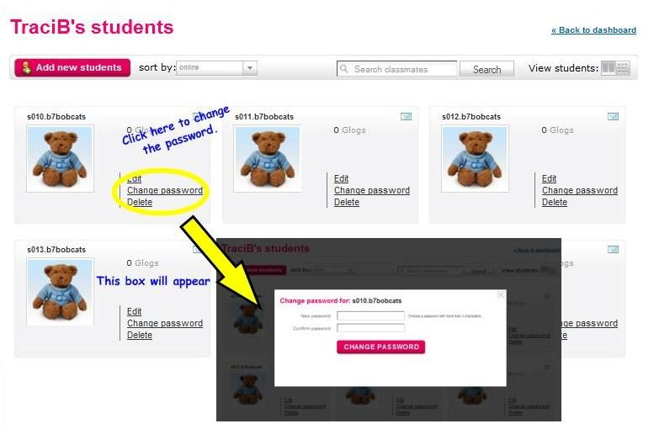  10. Click on CHANGE PASSWORD to change the password.
11. Now the fun begins! Click on CREATE A NEW GLOG to begin! | 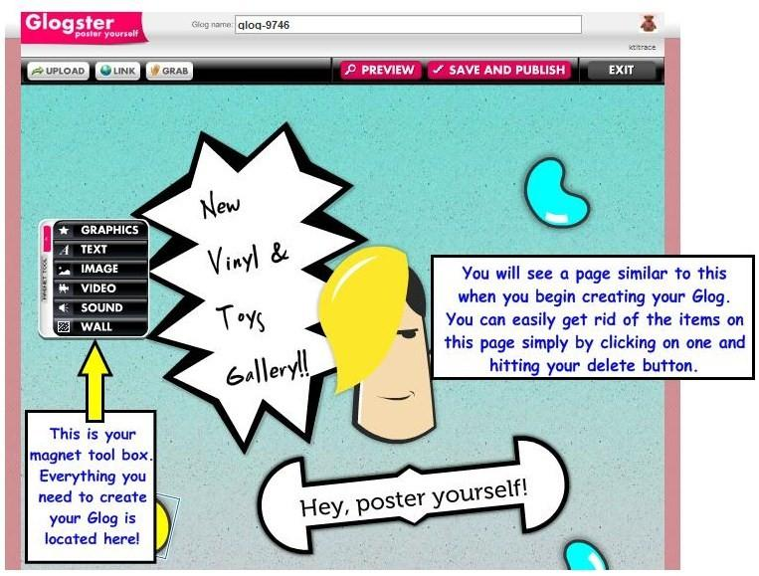  12. Use the black tool box to create you Glogster. Begin with the WALL, it sets your background. Keep building from there! Be creative and have fun!

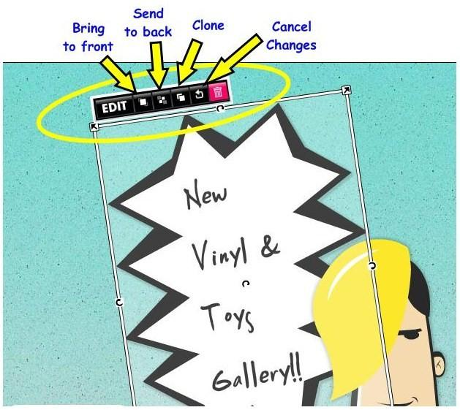  13. Change the layout, or click EDIT to make more changes. | 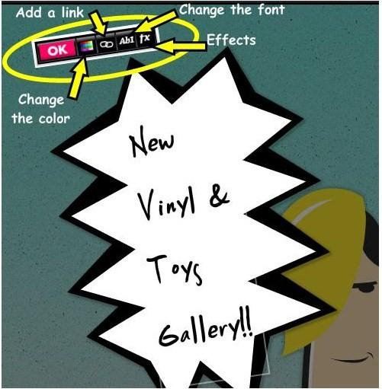  14. Change the color, font style, or add a link. Click OK when done.
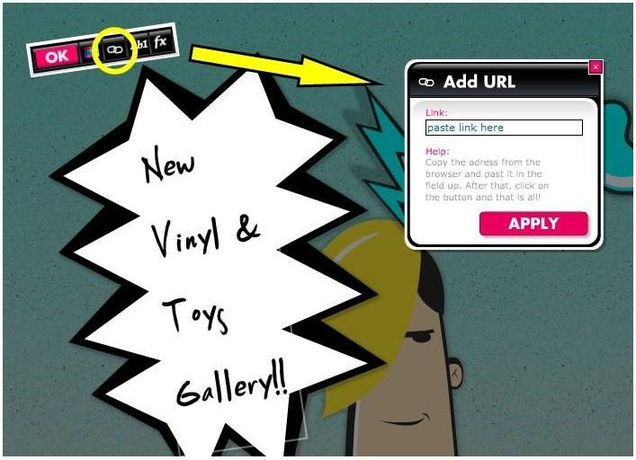  15. When adding a Link, paste the URL in the box. YOU WILL NOT BE ABLE TO VIEW THE LINK UNTIL AFTER YOU SAVE/PUBLISH THE PAGE! | 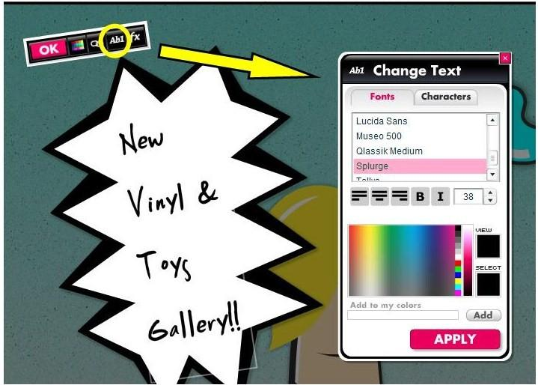  16. You can change the Font, Alignment, Size, and color here. Make sure you click APPLY at the bottom to save your changes!

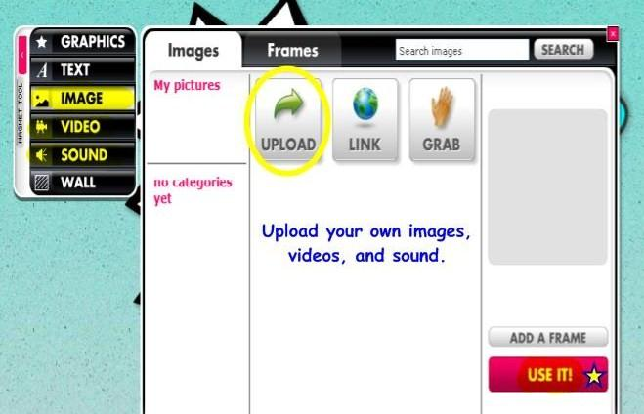  17. If choosing IMAGE, VIDEO, or SOUND you will upload the file. | 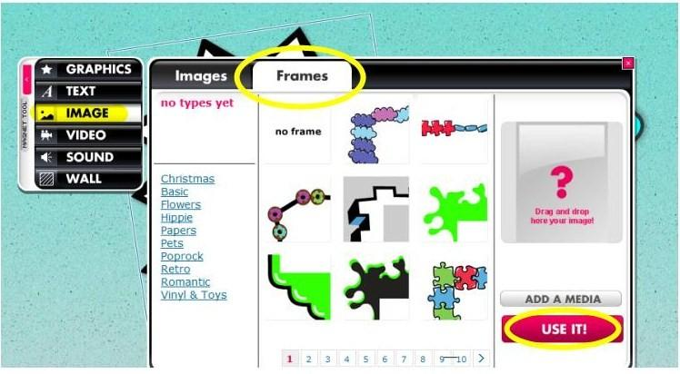  18. When adding an IMAGE, be sure to click on the tab to add a FRAME to enhance the appearance.
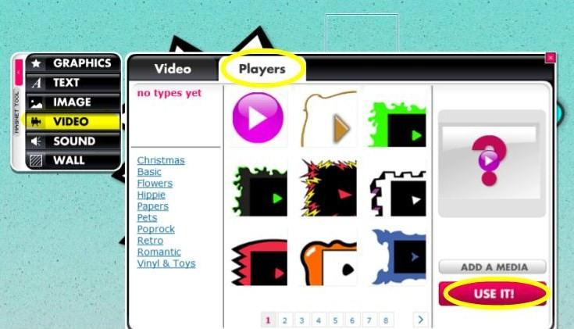  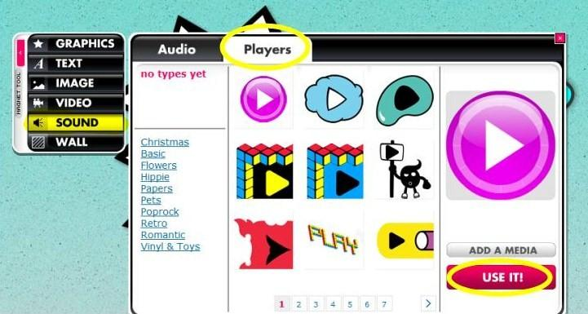  19. When adding a VIDEO or SOUND, be sure to click on the tab to add a PLAYER to enhance the appearance. | 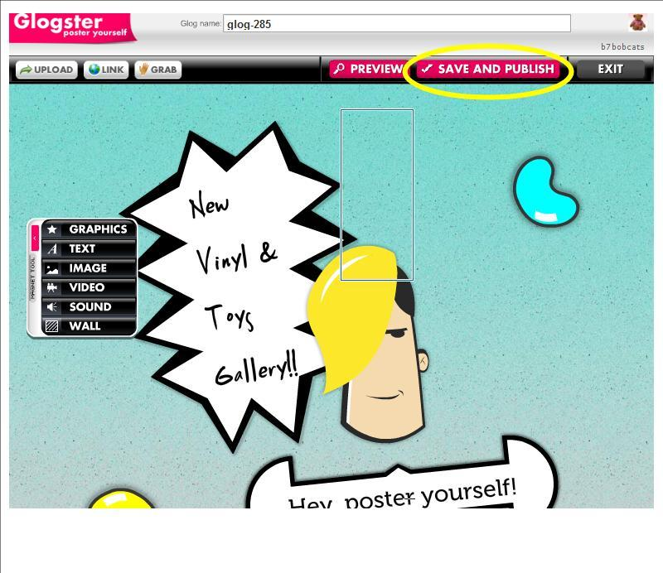  20. Click SAVE and PUBLISH to save your Glog.

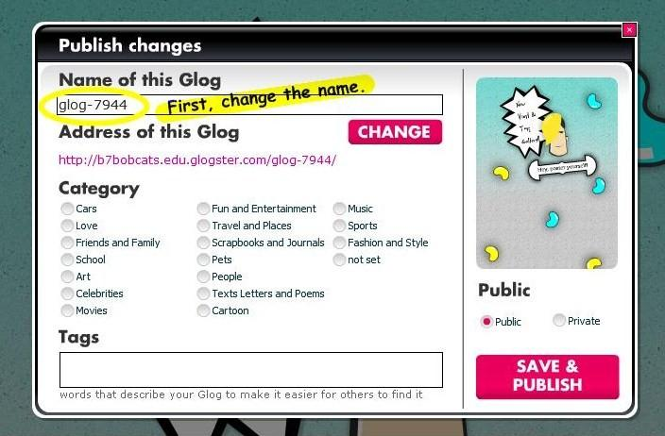  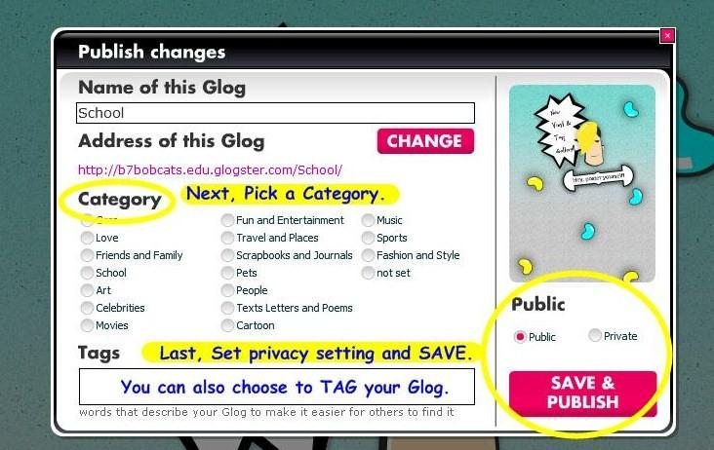  21. Name your Glog. Pick a category for it and set your Glogster's privacy to Public or Private. You may also choose to tag your Glog.Then, SAVE it! | 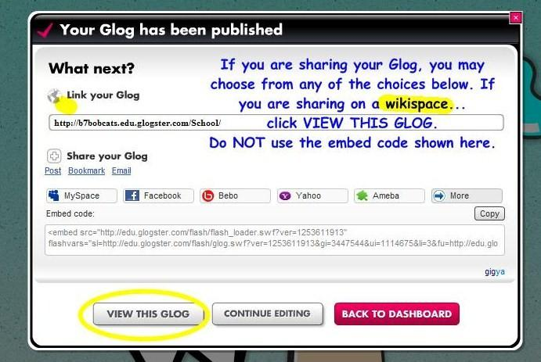  22. If posting your Glogster on Weebly... copy the Embed code, then drag a Custom HTML block from Weebly onto your Weebly page, and paste-in the code. Your Glogster should then display on your Weebly page.

