GoAnimate Instructions

Before GoAnimate: Script your duologue as a conversation between two persons, as directed by Ruie. The GoAnimate “quick video editor” limits you to 20 or 30 dialog lines depending on the template you choose, so summarize your conversation in 30 lines or less (i.e., 15 lines for each character). Each line can have up to 180 characters.

Log-In: http://goanimate4schools.com/school/itncsu
Your username is your first initial and last name, and everyone’s password is the word writing. Both username and password are lower-case.

Choose Template: From the green menu at left, choose “create.” Choose one of the “quick video maker” templates at the top of the screen. If you are confident in your tech skills and would like to try the “full video maker,” you can choose one of the templates at the bottom of the screen. I recommend watching the tutorial if you choose the “full video maker,” as the steps are more in-depth than the “quick video maker.” The steps below are for the “quick video maker” option.

Choose Setting: Choose a setting for your movie from the backgrounds or sets provided. Use the arrow keys to scroll right and left through the backgrounds. Click “next.” | 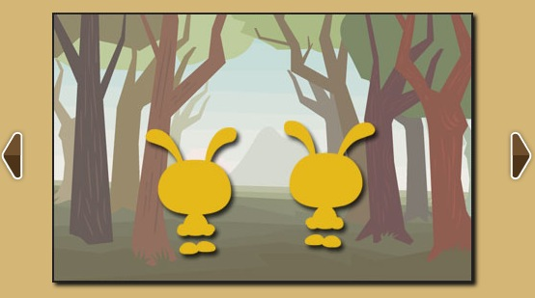
Choose Actors: Choose actors for your movie from the characters provided. Use the arrow keys to scroll right and left through the characters. | 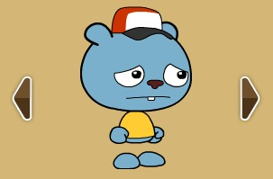
Type-in or Record Dialog: Type-in the text for your duologue, or find a quiet place and record your own voice speaking each line in turn. If you type-in the text, you can click “voice” to have your character speak in a different accent, including an English accent which might work well for this assignment. Note, you can also click “emotion” to have the character display a given emotion for a specific line of text.

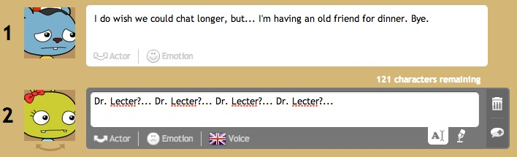

Finishing Up:
- Click “Preview” to generate a full motion preview of your movie.
  - Click “Back” if you wish to make any edits, or...
  - Click “Save Now” if you are ready to save your movie.
- Give the movie a title and description and click “Save and Go to Video Page.”
- Click “Post to a Group” and save your video to the class page ECI 519.

Please note, GoAnimate does not allow students to download or share submitted movies, so all you have to do for this assignment is save your movie and post to the group ECI 519 as instructed in the step above. The instructor will download and re-post your animation in the class YouTube account on Friday afternoon, where you can grab the embed code for your movie to share on Weebly. The class YouTube account and your movies can be accessed here: http://bit.ly/1peXH6X
In YouTube, click “Share” then “Embed” to copy the embed code for your movie, as shown below:

