Creating a Customized or Personalized Google Map

Getting Started: To create a personalized Google Map, make sure you are logged into your Google account, and go to http://maps.google.com/. Hover your mouse over the search bar, click the link that pops up to “my custom maps,” and click the pencil icon to “create” a personalized map.
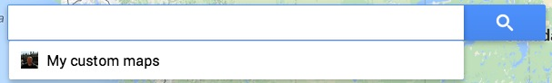

Title and Description: Click where the map says “Untitled Map” and give your map a name, such as “Kevin’s England Map.” You can also type a description here such as, “Descriptions and photos of places visited in England while on study abroad.”

Layers: By default, maps come with one layer. You can add up to three layers in a free map, without upgrading to Google Maps Pro. I suggest having one layer of “Places Visited in Guildford,” one layer of “Places Visited in London,” and one layer of “Other Places Visited in England.” Go ahead and name your layers now and get them set up in advance.

Placemarks: Before adding a placemark to your map, make sure you have clicked and highlighted the layer you want to add your placemark to. You can’t move placemarks between layers, so they need to be added to the right layer to begin with. After clicking a layer to highlight it, you have two options for adding placemarks to your layer, by searching for a placemark and adding it to your layer, or by adding your own placemark to the layer. These different steps are explained below:

If you are adding a placemark for a location that is relatively well known, you can search for it using the search bar at the top of your map. For example, Google Maps can find places like The University of Surrey and Guildford Castle. Search for an item, click the result, and a green placemark will appear on your map. Click the blue link “add to map” to officially add this place to your map, and the placemark will turn red and appear under your layer.  Click the placemark icon at any time, then the pencil icon within the placemark, and you can edit the title and description for that place. | 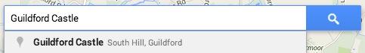  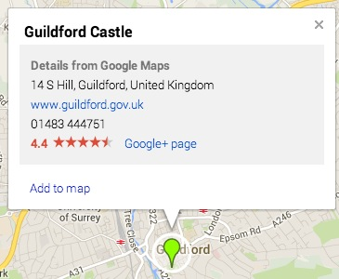  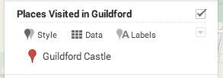

If you would like to add a non-known location to your map, such as the statue at Guildford Castle of Alice through the Looking Glass, you first zoom into the location you want to add a placemark for using the plus arrow to zoom, then you click the marker icon from the Google Maps menu and click again on the map where you want the marker. Add a title and description.

Getting Your Photos on Your Personalized Google Map Placemarks

To add one of your photos to a Google Maps placemark, you will need a URL for a given photo that ends in a photo extension such as JPG or PNG. Unfortunately, you can’t just upload photos to Google Maps, you have to tell Google Maps where to go online to find your photo. For example, here is the URL ending in JPG for one of my photos of Guildford Castle on the photo-sharing site Flickr: https://farm7.staticflickr.com/6124/6011578473_a0dd66f7fd_m.jpg

So the first step is to set up a free account on Flickr, and upload the photos you want to use for this assignment to Flickr (http://flickr.com). Yes, other photo-sharing sites may work just as well (Picasa, PhotoBucket), but these directions are for Flickr.

After uploading your photos to Flickr, click to open any single image, and you will see a set of icons like those shown to the left. Click the arrow icon in the middle.
To get the link to your image that ends in JPG, you need to click the link for “HTML,” and copy ONLY the Web address that appears after the words “img sre.” For example, you will copy a URL like this:  https://farm7.staticflickr.com/6027/6012125494_5e35d063c4_m.jpg | 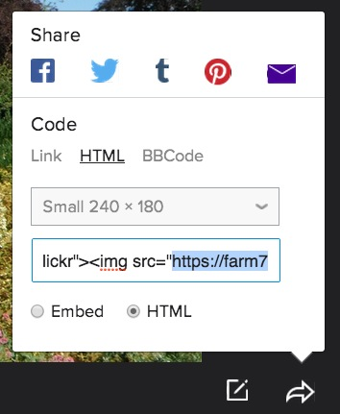
Now back in Google Maps, you open the placemark you want to add an image to, and click the photo icon in the lower right-hand corner. | 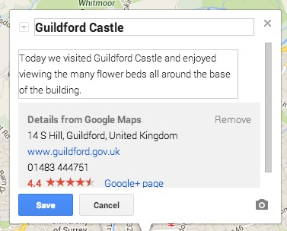
Choose the Image URL option, paste the URL you just copied to your image in the box shown, and click “Select” at the bottom. Your image should now appear on your map. | 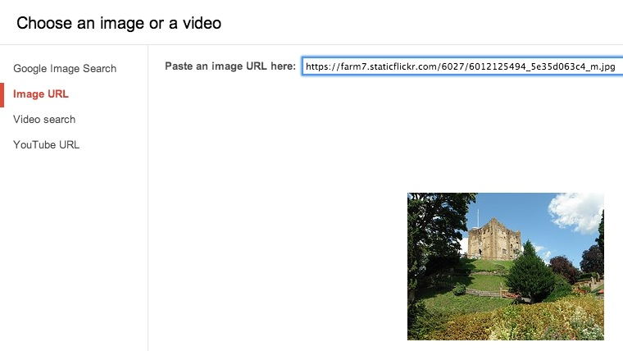

Embedding Your Map on Weebly

When finished editing your map, first click “Share” in the upper right-hand corner, and change your settings to public on the Web, so the public can view your map. | 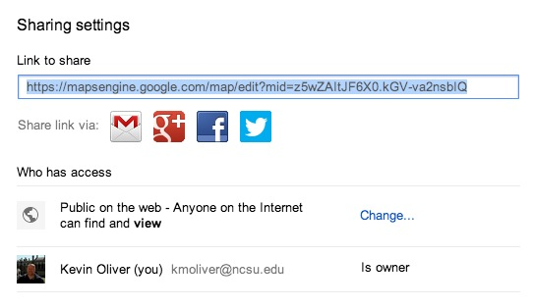
Second, click the folder icon under your map’s name, and select “Embed on my site” from the list. Copy the Embed code shown, and use this code with an HTML block in Weebly to add your map to your Weebly portfolio. | 