Lego Story Starter Kits and StoryVisualizer Instructions

Lego Story Starter kits are available for purchase from Lego Education. The kits are intended to prompt students’ ideas for writing original stories. The kits work in tandem with a mobile learning app called StoryVisualizer available on the iPad. Basically, students write a story as prompted by items in the kits, they build lego sets to depict different scenes in their story, they photograph individual scenes and drop them into a comic-like format in the StoryVisualizer app, then they add text bubbles and graphics to finish their stories. Stories can be exported as PDF documents or image files for printing or embedding on Web sites. A sample, finished story is shown below:

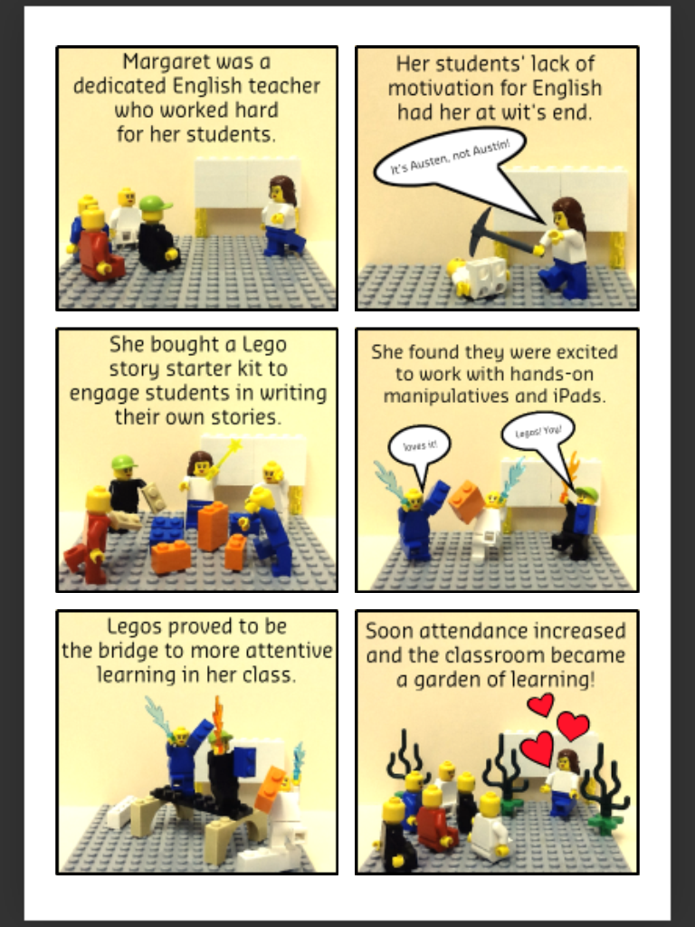

To get started, refer to the Jason Ohler story diagram at right. Look in your story starter kit to find inspiration for writing a simple story with a beginning, tension, conflict, resolution, and closure. Using the Ohler diagram provided in class, write the script for your story at different points along the transformation continuum. | 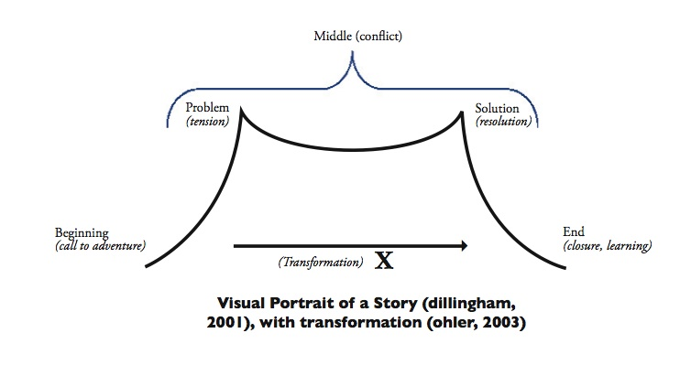
When your script is written, open the StoryVisualizer app on your iPad and click the “plus” sign to start a new project. | 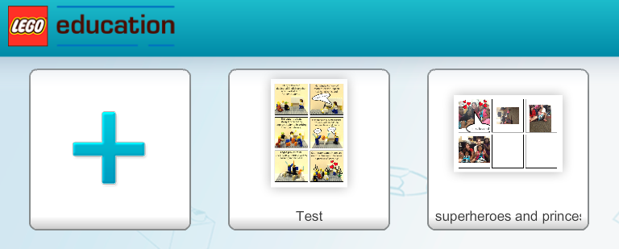
You will be asked if you want a vertical or horizontal layout. Tap one and tap the check mark to continue. | 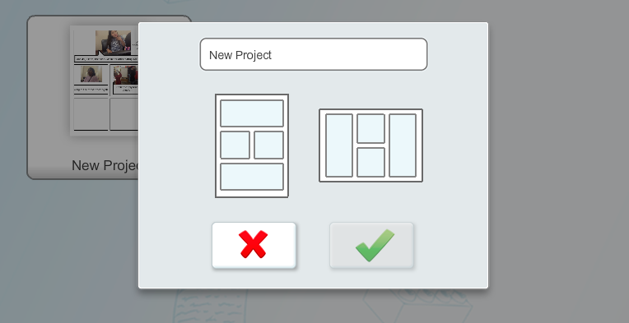
Next, you will be asked what layout you want for your story. If your story has five scenes as recommended by the Ohler framework (beginning, tension, conflict, resolution, and closure), tap a layout with five frames, and then tap the check mark to continue. | 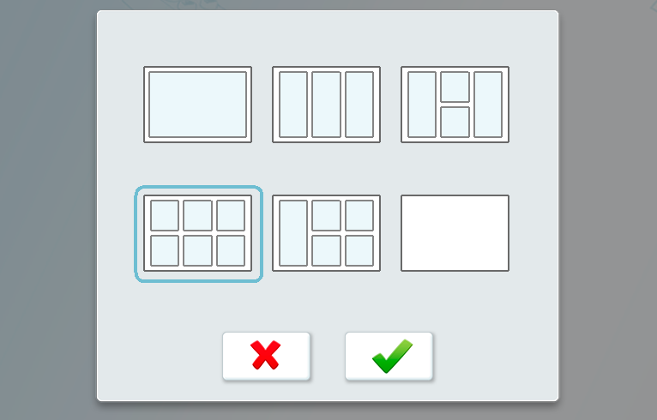
Your layout will display. Tap any one frame (box) to open the edit options for that frame.

Outside of StoryVisualizer, go ahead and build the set for your first frame with legos. Place your set in front of or on some background that will look good when photographed. For example, place an open, legal-sized file folder on a flat surface and put your lego set in the fold of that folder, so the back half of the folder is visible behind your scene. This setup will photograph well.

When finished building your first scene, return to these instructions.
When your first set is ready to photograph, tap the person icon shown at right in StoryVisualizer, then tap the camera icon.  Photograph Tip: If you leave some blank space at the top or bottom of your scene in the photograph, this will give you a place to insert text later in this process. | 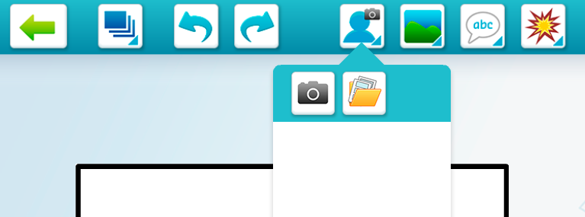
Take a photograph of your first set and tap “Use Photo.” If necessary, use the arrow keys to flip the photo until it is shown in the correct, upright position. Finally, click the check mark. | 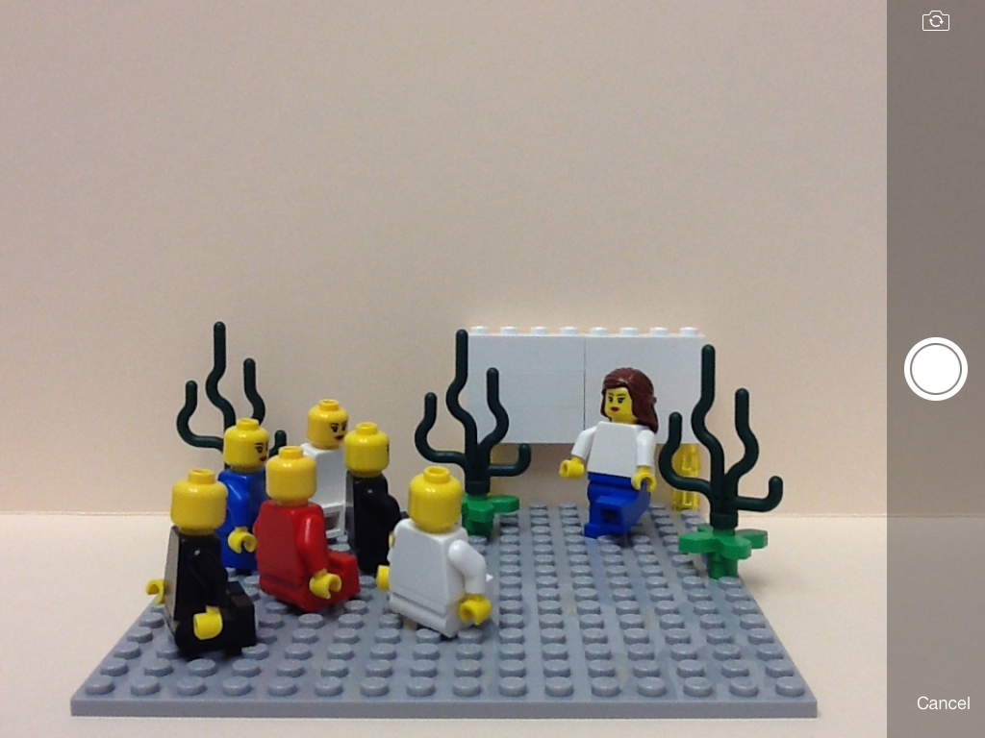
Your image should now appear in the image library as shown at right. | 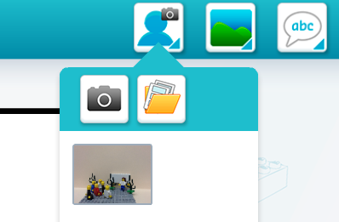
Simply tap and drag the image from your image library to insert it on the open frame. | 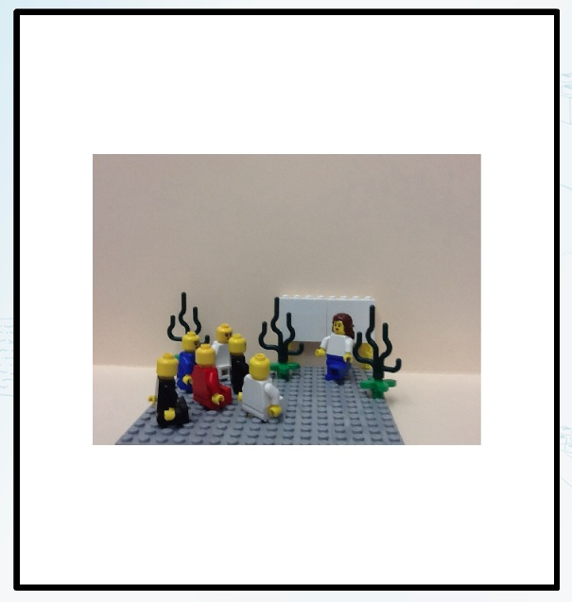
Once on the frame, you can drag the image around to place it appropriately, and you squeeze two fingers together while touching the image to shrink its size or move two fingers apart while touching the image to expand its size. Try to fill the frame completely for the best look.  If you are unhappy with your exposure, click the icon under the trashcan where you can change the lighting levels and make the scene lighter or darker. | 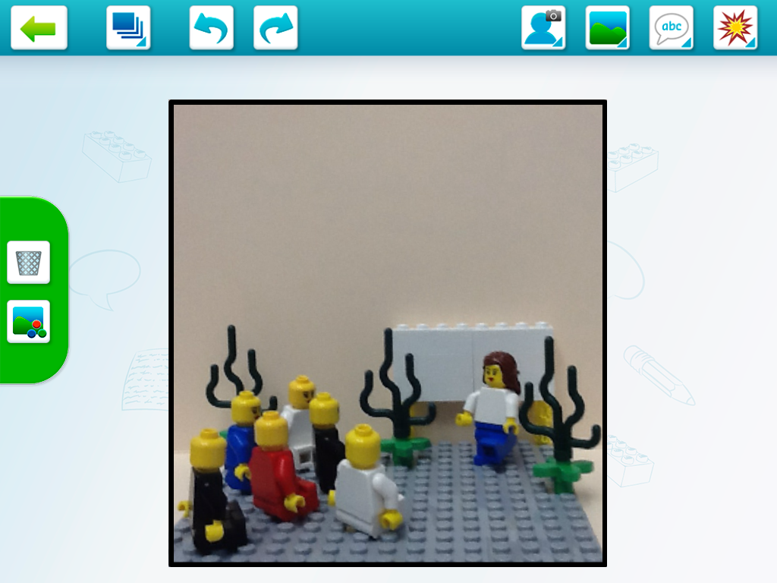
Now you are ready to add your script to your scene. Tap the text icon on the upper menu, and choose any of the options provided. Text bubbles can be arranged, so that they appear to be coming from individual characters in the set. Or you can just have text floating above the entire scene in general.  When you tap a text type, it will insert sample text on your frame. | 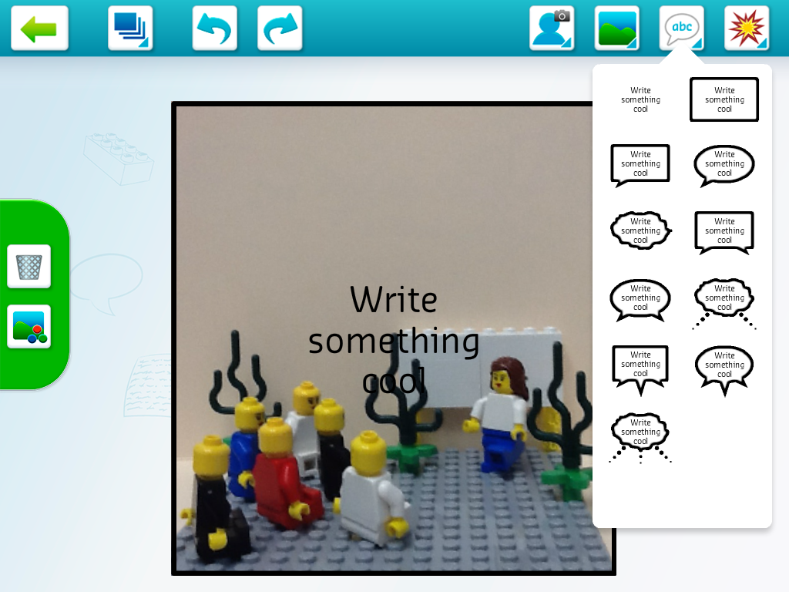
Tap the sample text to open the editor and type in your new text. Rather than typing the text as a long paragraph, you may need to tap “return” after every so many words, so that it fits in your frame better. This will take some experimentation.  When finished adding your text, tap the “down keyboard” icon in the lower right-hand corner of the screen to insert your text and close the text editor. | 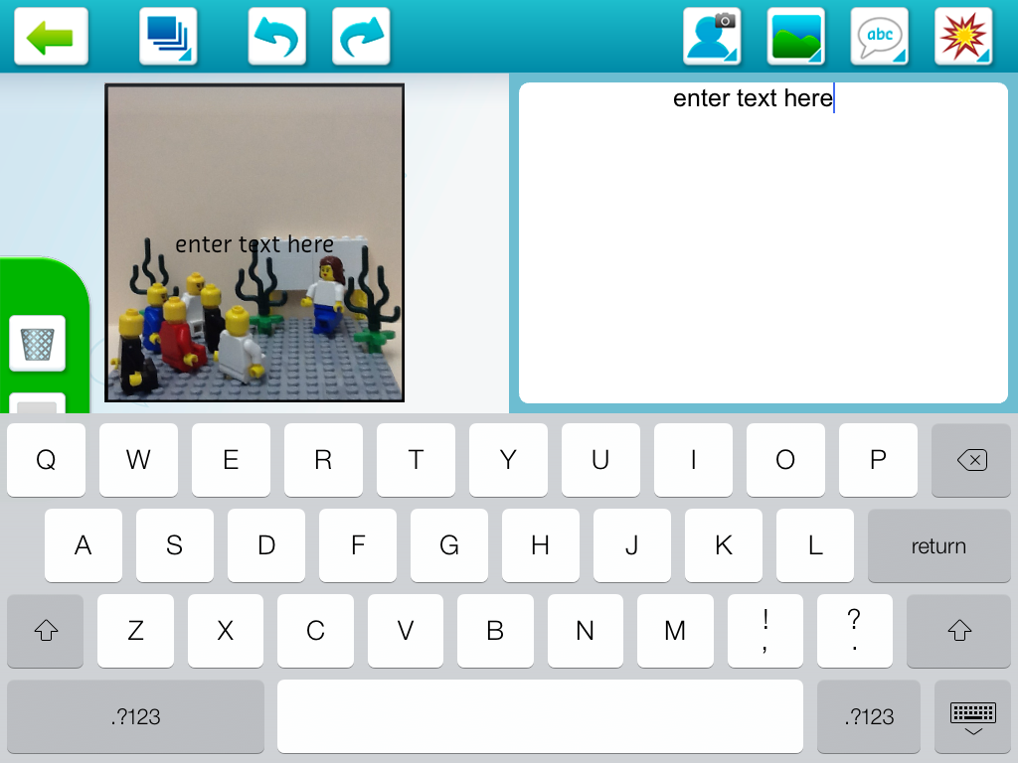
As with photographs, you can tap and move text around in a frame so that it appears clearly where you want it to, and use your fingers to expand or decrease the size of the text block. | 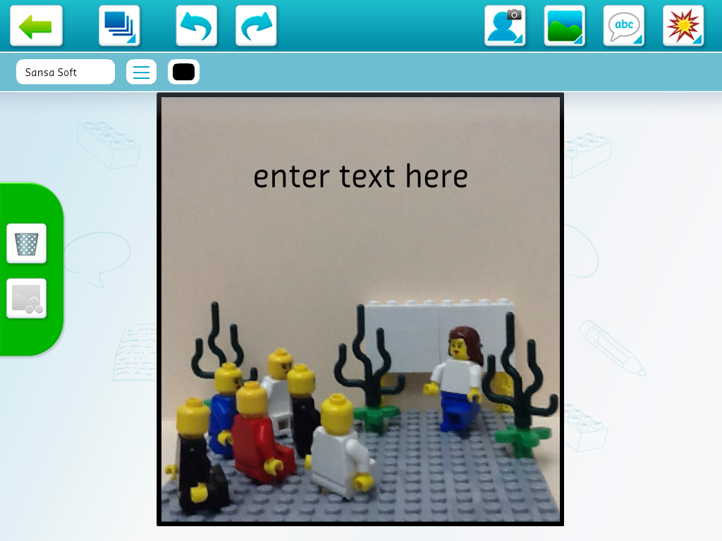
Note, in a given frame, you can add graphics (clip art) and different graphical backgrounds, using the icons shown at right. This might come in handy on some projects, for added detail or effect. | 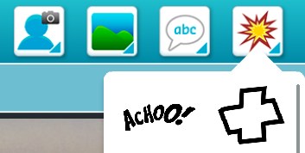  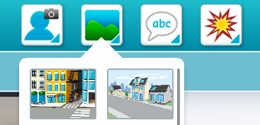
When you are done with all of your edits on this single frame, click the arrow key in the upper left-hand corner of the application to return to your overall layout. You should see your first frame completed. Click the frame to make more edits, or click a new frame to work on.  When completely finished with your project, you click the PDF icon at the top to email a copy of the project to yourself (note: may not work if iPad is not set up correctly). Alternatively, you can click the home and power buttons on the iPad at the same time to capture a screen shot of your completed project. See the instructors for help getting a copy of your project off the iPad to place on your Weebly portfolio. | 