lettrs.com is a Web-based tool you can use to craft, what else, LETTERS! It is very easy to use. Here are some simple steps:

Create an account on lettrs.com, log-in, and then click “write a letter” at the top of the screen.
You can start writing immediately, or you can select a new “theme” for your letter, which is like different kinds of stationary with different backgrounds.
As you start typing out your letter, you have a variety of options available to you. From the menu above the letter, you can choose “paper clip” to add a photo to your letter, just like you might enclose a photo in a real letter. If you choose “tags,” you can add keywords to your letter that might make it easier for people to find it (assuming you wanted to publish your letter broadly--more on that later). If you choose “locate,” you can add location information to your letter indicating from where you are writing. This would be handy if you are mailing virtual letters home from travels abroad (i.e., today you are getting a letter from Rome, tomorrow from Florence, etc.).
If you start typing a letter and need to step away, you can click “finish later,” which will place your letter in a “drafts” folder. If you are finished with your letter, you can click “choose delivery” to select send options. lettrs.com gives you three primary delivery options:  - have your letter printed (by them) and mailed to someone (by them) for a fee  - have your letter digitally delivered to an email address, Facebook friend, or LinkedIn connection (free)  - have your letter publicly published on the lettrs.com Web site which the entire community can see and read (free)  Most of you will want to choose “digital delivery” to friends, family, or yourself. Note, you can future-date your letter and have it sent on a specific date. For example, an assignment like “letter to self” can be future-dated to arrive after we return from England, to reflect how your impressions of England have changed since you traveled abroad. | 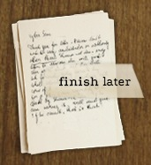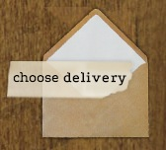

Advanced Features:
If you roll your mouse over your user name at the top of the screen, you will see the main settings menu as shown at right. This is where you access your different “spaces” for storing, publishing, or even receiving letters:  - fridge is the space where any letters have been published publicly or uploaded through the preserve feature described above  - drafts is the space where you retrieve letters in progress that were saved before they were finished  - kitchen counter is the space where you receive letters from friends you have that are using lettrs.com, and this would be a great place to have students exchange letters with peers or with key pals in another country  - shoebox is the space where you can store private letters you wrote or letters you uploaded through the preserve feature that you wish to remain private  - desk drawer is a place to see all the letters you’ve saved and sent  - address book is a space to keep track of your friends or pen pals also writing with lettrs.com | 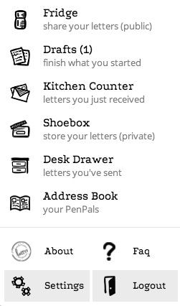

Letter to Self, Writing Prompt

To get started, write down, pell-mell, everything that comes into your head, using the first words that occur to you and without concerning yourself about grammar, spelling, form, and continuity. You are clearing your head through writing. This should be a kind of fast note-taking to get down as much as you can of what you think, feel, and sense. Eventually, you will find a focus to this letter to self. With that focus in mind, continue to elaborate in writing.

Here are some suggestions that might help you find a focus:
- Make a record of yourself on this day: how you are feeling physically, what makes you happy, what stresses you, what you want to learn, how you want to grow, etc.
- Set a few goals that you hope to reach before you depart (e.g., plan fall syllabus, pack early, visit family, find a pet sitter, etc.)
- Describe your expectations and anticipations about traveling abroad. Do you anticipate that you will be changed in some way?
- Set a few goals for the travel abroad. For example, consider a plan just for yourself about what you might want to accomplish or experience on this trip (e.g., finding a strength you have; exploring a place that you have only read about; interacting with strangers in a new way; etc.).

