Assignment 13: Meme Generator

In place of assignment 13 (Impressions of England Glogster), we’ve decided to introduce you to a different tool called Meme Generator, which will allow you to generate artifacts with your impressions of England, albeit in a different sort of way!

A meme is an element of popular culture that gets propagated or takes on a life of its own. Memes can be signs (RELAX t-shirts from the 1980s), fashion trends (Member’s Only jackets from the 1980s, backwards baseball caps), popular quotes from movies (“Luke, I am your father!”), and most commonly imagery that goes viral through social media including still images (the Raleigh snowpocalypse on Glenwood Avenue) and videos (that drugged-up kid whose father filmed him in the back seat of the car after a trip to the dentist).

An understandable meme can be difficult to create, as they usually assume someone understands the visual reference point. They can be lost in translation across cultures, places, races, ages, etc., if a viewer has never seen the source image in any context. If you’re on Facebook, you’ve probably seen these Willy Wonka and Reagan memes, and understand the usual connotation is patronization and deception.

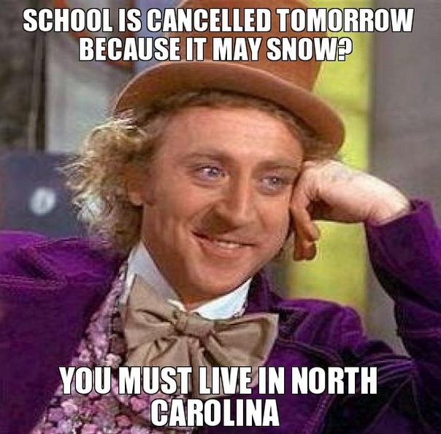

Or you may have seen these memes from Game of Thrones and The Matrix that help to convey frustration and mind-blowing situations respectively:

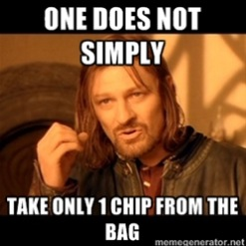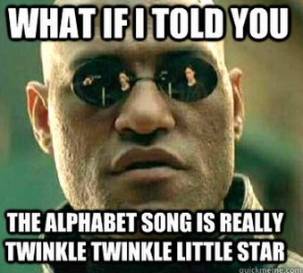

If you would like to see some of the more popular meme images, navigate to http://memegenerator.net, click the “God tier,” “Demigod tier,” “Legendary tier,” and “Top tier,” then click individual images to see hundreds of examples of how a given image has been used to convey a certain message.

The Assignment

Your goal for this assignment is to prepare two England-themed memes (or other country you’ve visited on this trip) that illustrate your growing understanding of two different facets of another culture, then share the images with the class on a Padlet wall. This assignment requires you to convey at least two things you have learned about another culture during your time abroad. You don’t have to use England-only images (e.g., Margaret Thatcher, Queen Elizabeth, Wayne Rooney), but the two concepts you are conveying should be England-themed. For example, you may have experienced many poorly behaved children in England who have led you to the assumption that this is a “spare the rod” society where little Elton or Lilly can do no wrong. In which case your first meme might look something like this:

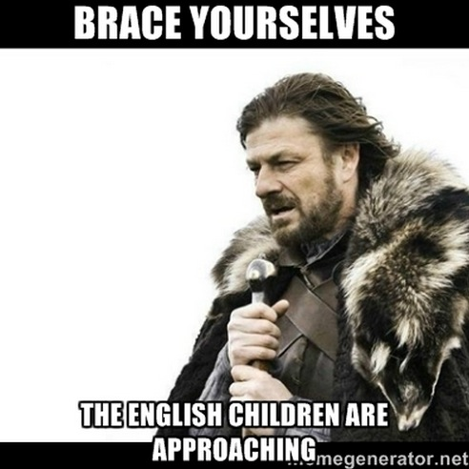

Step 1, Write*: Think about two cultural concepts you want to convey, and write some sample text for each. You must be brief, as only small amounts of text will fit over most images.

Step 2, Select Images*: Think about images that would help you convey each of your cultural thoughts, something from popular culture ideally, that have the same “feeling” you are going after (e.g., dread, condescension, lost hope, adoration, coolness, deep thought, geeky, creepy). Go to http://memegenerator.net/ and click “generate an image.” Next to “select a meme,” you can enter search terms to find images in the Meme Generator library that are relevant to the concept you want to convey (e.g., Willy Wonka, Game of Thrones, Austin Powers, Dr. Evil, Spice Girls, James Bond). If you can’t find anything that works in the Meme Generator library, you can click “create new character” and upload your own image (e.g., something you found online somewhere else).

*Note, it may be easier to swap steps 1 and 2 above (i.e., looking at some of the images in Meme Generator may remind you of a cultural experience or understanding in England).

Step 3, Text Over Image: With an image selected or uploaded, enter your top and bottom text, click the English flag to generate your meme in English, and click the “Generate” button.

Step 4, Copy Finished Meme: Unfortunately, Meme Generator doesn’t make it easy to get your images off their site, so you have to do a partial screen capture to copy the image. On a Mac, you click Command-Shift-4 and drag the cursor around the image. For other computers, here are general screen-grab instructions: http://www.take-a-screenshot.org/

Step 5, Add to Padlet: With your image downloaded, go to Padlet and add your image to our class wall at: http://bit.ly/1oHSQeg

Step 6, Explain Yourself: Include three things in your Padlet description... your name so we know who shared which memes, descriptive text explaining why you chose a specific image for your concept so your meme doesn’t get lost in translation, and either the numbers 1-2 or 2-1 indicating if your meme was generated by writing first (i.e., step 1 then 2) or by searching for images first (i.e., step 2 then 1). We’re interested to know how most folks come up with memes--by writing first or by finding images that inspire them to write.

