Assignment 8: Design A Dream Room Writing and Pixlr Collage

Overview: Pixlr is a simple Web-based application that allows you to work with images, create different layouts or collages with multiple images, and overlay text on your images. Today we would like you to take the text from your Design A Dream Room writing, capture or locate images that help to illustrate your text, and merge the two (text plus images) as a Pixlr collage. Let’s get started by capturing or finding pictures that help to illustrate your Dream Room text.

Step 1: Images  Option 1: Capture your own images. We have provided for you in class today a set of portable dry erase boards and markers that you can use to capture pictures of yourself with words, or pictures of objects with words, not unlike the examples shown to the right. This is a great way to build simple picture strips, and Pixlr’s collage feature makes it very easy to produce picture strips. Perhaps this option will work for you to illustrate your dream room, or at least you can capture an image of yourself introducing “My Dream Room” as the first title slide in your collage.  Option 2: Search for images. It may be much easier to illustrate your expressive “dream room” text using images found online. To that end, we suggest you use Flickr to find images that are copyright-free and licensed in the Creative Commons. To get started, go to http://flickr.com enter your search term in the search box, and click the magnifying glass to initiate the search. | 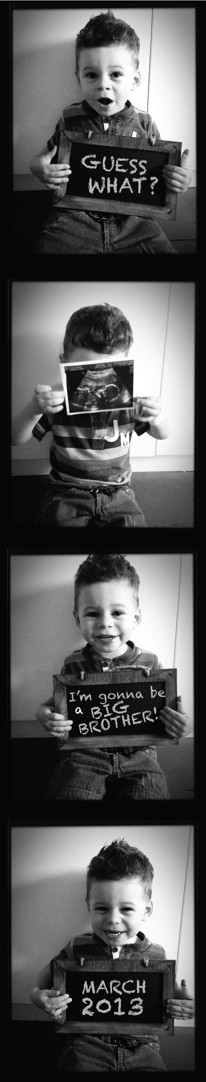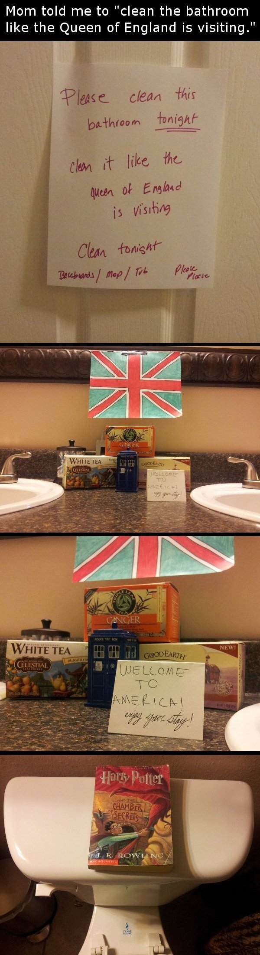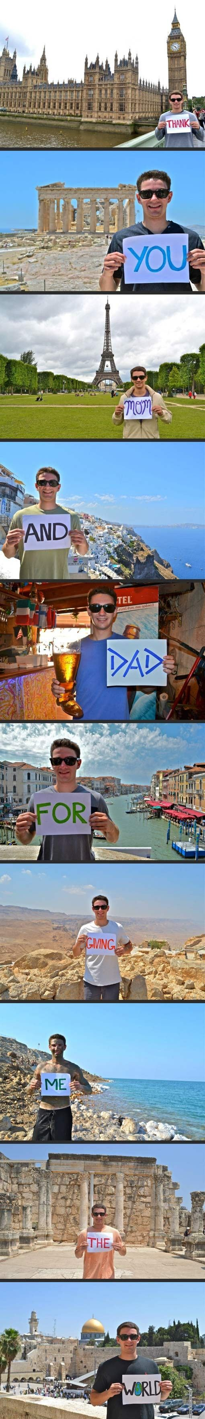
Many of the images that appear after you search are copyrighted, and it’s not okay to use them in your multimedia project. Instead, click the “advanced search” link in the right-hand corner of the screen, at the bottom click “only search within Creative Commons-licensed content,” and click “find content to modify, adapt, or build on” which ensures the images that appear can be manipulated and worked with in your Pixlr collage. Click “Search” and now you may choose any photo to include in your collage. |  | 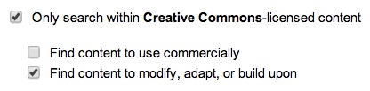
Once you’ve found a photo you like, click it once to open it, and click the icon with three dots to pull up “more actions.”  Click “download all sizes” to view different sizes for download, and download the small size for your collage (square 150x150). Chances are the smaller sizes will work better within your collage, but you can come back and download a larger size if you need it later. That’s all there is to downloading copyright-free images from Flickr to re-use in Pixlr. |  | 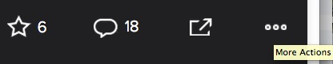  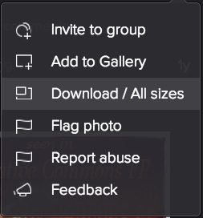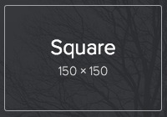

Step 2: Pixlr

Pixlr (http://pixlr.com) is a free online photo editor that allows users to edit, adjust, and filter images directly in a browser without requiring registration or sign up.

Writing Tips: Picture strips in this class can be expository and relay factual information (e.g., you are standing in front of Big Ben and indicate how old or tall it is), poetic and relay creative text (e.g., you are standing in front of Big Ben and were inspired to write a haiku), or expressive and relay personal experiences and reflections (e.g., you are standing in front of Big Ben and describe your personal observations and/or feelings from the experience). Regardless, you should plan text segments that are SHORT with just a phrase or one-two sentences at most. Otherwise when you drop these pictures onto a tiny square in Pixlr, the text will NOT be readable. Be brief, not overly flowery! If you must be flowery for the sake of expressive writing, consider using two pictures to capture the full thought, not just one.

Photography Tips with Portable White Boards: When writing your text on the portable white boards, please note that Black, Blue, and Red markers will show up much better in photographs than Green. We suggest writing in Black or Blue. Also, when photographing a peer holding a portable white board, make sure the person holds the white board as close to their face as possible just under or beside the chin, while still showing anything in the background that is relevant (e.g., Big Ben). Also, zoom in on the person’s face and white board as much as possible. Remember you will be placing these photographs on a tiny square in Pixlr, and you want them to be readable, so zooming out to capture an entire scenic view will simply not work if you have much text at all. Rule of thumb--with a few words, you can show more background and still be readable, but with more words, you will have to zoom in closer to the white board with less background visible. Finally, note how different facial expressions and orientations can really be used to complement the text (and should be).

Layout Tips: Picture strips with four or five images/boxes that are created in a horizontal alignment will embed better on Weebly portfolios than picture strips created in a vertical alignment (i.e., you can read the whole strip from left to right without scrolling down on the Web page). If your picture strip needs more than 5 images/boxes, just create two separate horizontal strips of four or five images, and embed them one after another on Weebly. Sketch out how many images/boxes you need in advance based on your writing. | 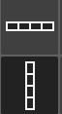
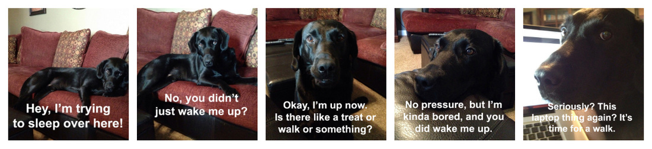

There are four options for using Pixlr:  - Editor--advanced photo editor with a “professional touch” http://pixlr.com/editor  - Express--efficient photo editor with a “professional touch,” http://pixlr.com/express (use this option for your strips--see next page)  - Pixlr-O-Matic--edit photos with cool effects like vintage and retro snaps; apply filters, lightning, and borders, http://pixlr.com/omatic  - Mobile--download Pixlr Express or Pixlr-o-matic for Android or Apple phones from Google Play or the App Store, http://pixlr.com/mobile | 