Four steps to sharing a Google Doc and posting on Weebly

First, with the document open, click blue "share" button in upper right-hand corner. Make sure the setting is "anyone with the link can view" as shown below...
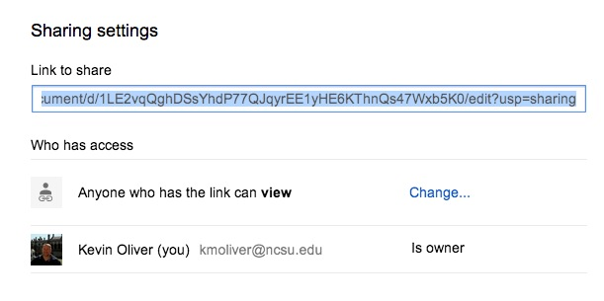
Second, choose File < Publish to the Web from your Google Docs menu, check off the settings as shown below, and copy the line of "embed code." By selecting "automatically republish," you can continue to make changes to your document in Google Docs, and anywhere you've embedded your doc such as your Weebly portfolio, the changes will automatically be reflected in those embedded places without you having to go through these steps every time you make a change (e.g., to your course journal with reflections on readings as you add them throughout the summer).
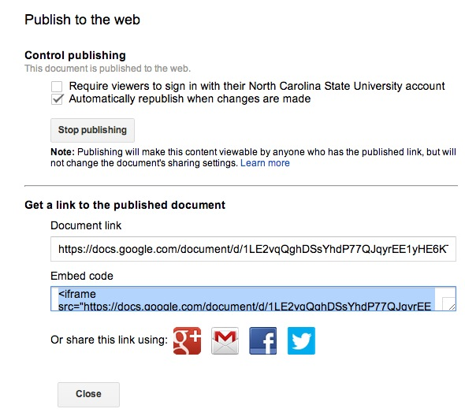

Third, in Weebly, click the "embed code" block from the menu and drag it over onto your Weebly portfolio where you want the document to display. Click the block and paste in the embed code you copied in step two.
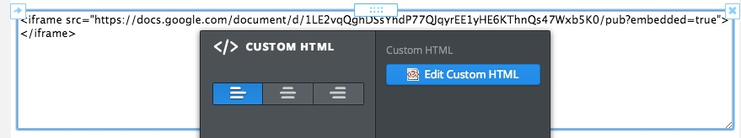

Finally, since the Google Docs embed code is fundamentally flawed and contains no dimension elements, the document itself will display rather poorly (squished if you will). So you have to tweak the code by adding a few pieces of information to stretch the document out normally for ease of readability/grading. Add "width=800" and "height=600" or some other pixel values at the end of your line of embed code to expand the width of your document, as shown here: <iframe src="https://docs.google.com/document/d/1LE2vqQghDSsYhdP77QJqyrEE1yHE6KThnQs47Wxb5K0/pub?embedded=true" width=900 height=600></iframe>

That should get your document embedded in Weebly correctly, in a format the instructors and your peers can read.

