Step-by-Step Instructions for Recreating Your “Where I’m From” Poem in Prezi

To get started, set up a new account at http://prezi.com and click on “New Prezi.”
You will have the option of working with a template, or simply starting a blank Prezi. Templates are pre-loaded with graphics and a defined set up “frames” where you insert text and other media elements, so sometimes they are more difficult to edit and work with than if you just start a blank Prezi. Especially if you are working with something like the “Where I’m From” poem, when you have a specific set of stanzas that you will want to convey, which may or may not match up with a template. In short, I recommend you start with a blank Prezi. | 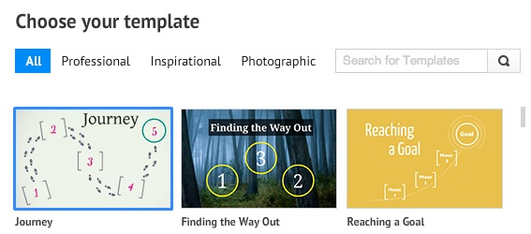
A blank will start off by giving you one frame to edit. You can put the title of your presentation here (e.g., Amy’s Where I’m From Poem).  Notice the frame (circle) has a number, which references the “path” of your presentation. You will number specific items in your Prezi to play along a “path” in a numbered order. | 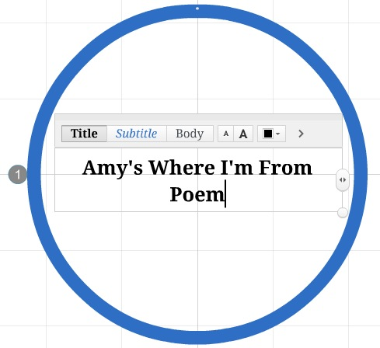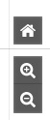  ^  It’s not obvious, but hover your mouse cursor over the right-hand side of your Prezi to see zoom in and out buttons that will allow you to see more or less of a given Prezi screen. Zoom out to give yourself more room to add a second frame.
On the menu, click “Frame” and then click “Add Frame.” This will insert a new frame in your Prezi.  You can click the corner of a frame to see a pull-down menu that will allow you to change your frame to a bracket, circle, rectangle, or invisible.  Insert the first four-lines of your Where I’m From Poem here.  If you don’t need a text box, right click and select “Cut.”  After you’ve entered text, you can make the font size bigger or smaller, different colors, and enlarge/shrink or move the text box around, until it looks right. | 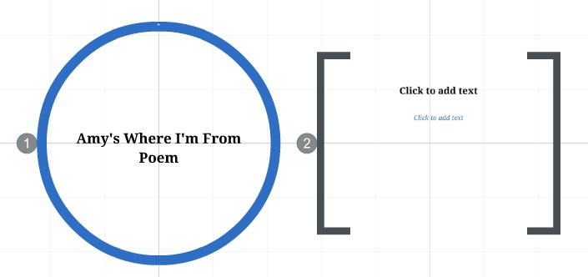  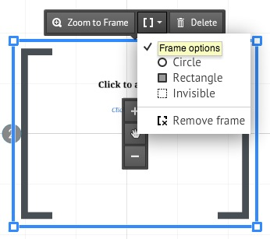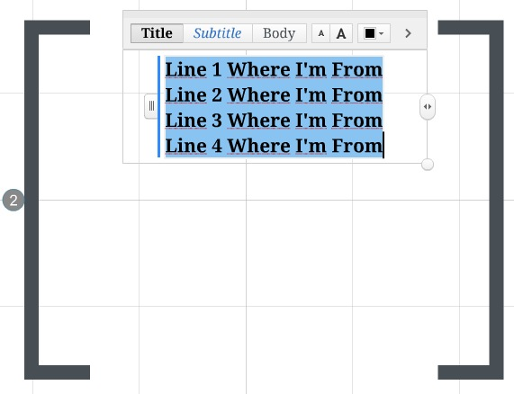
Within a given frame, you can insert a variety of media, including images. For each four-lines of your Where I’m From poem, try to find a photo from home or an image that relates to your line. You can also use video if you wish. Insert these items in the same frame as the text.  Continue to add more frames, more poem lines, and more images until you finish the entire Where I’m From poem. You may need 10-15 frames to finish the whole thing. | 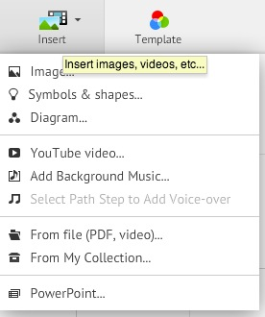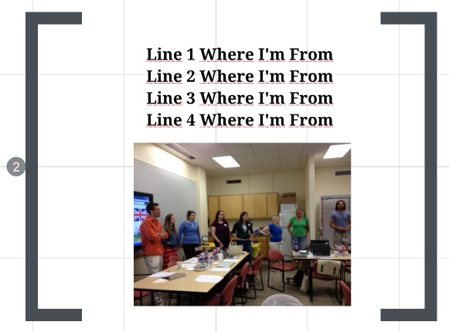
Along the left-hand side of your Prezi, you will see a “path editor.” New frames should be automatically added to your path, but if you ever need to add something to your path that isn’t showing, or if you need to renumber frames, this is the place to do so. Click “Edit Path,” make your changes, and click “Done” to return to Prezi edit mode. | 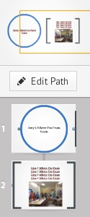
You will want to embed your Prezi in your Weebly portfolio. To do so, save and exit the Prezi edit mode. Go to your list of Prezis on the home screen. Click to open a given Prezi and at the bottom of the screen, click “Embed.” Copy the embed code and paste it into a HTML block back in Weebly. This should pop-in your Prezi on your Weebly page. | 