TimeToast Instructions

Project Overview: To prepare for this project, you will need to collect expository dates and facts from a selected literary figure or historical site.

Step-by-Step Instructions: Sign up for a new account at http://www.timetoast.com/
You will need to confirm your email address, and then log back into your account.

To make a timeline, click on “your timelines” in the upper right menu, and then click on “add a new timeline.” You will be asked to provide a title and category (probably “history”) as well as an overall picture for the timeline. Note, the “simple uploader” for photos seems to work better. Click “go” and you will see your new timeline. | 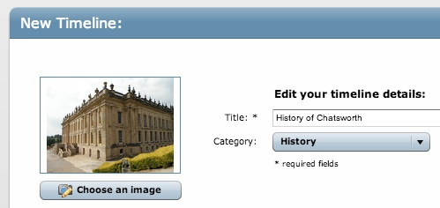
At the bottom of the form, click on “add timespan.” You will again add a title it and then the start and end dates defining the parameter of your timeline. You may add introductory/overview text and a link. | 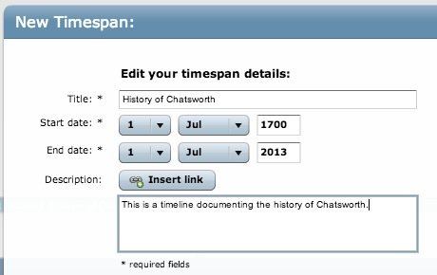
Create events by clicking on “Add Event.” Each event will appear as a black circle. You will be asked for an event title, specific date (day, month, and year), and a description. You can upload images for each event. We suggest creating a folder ahead of time that contains images you can choose from. | 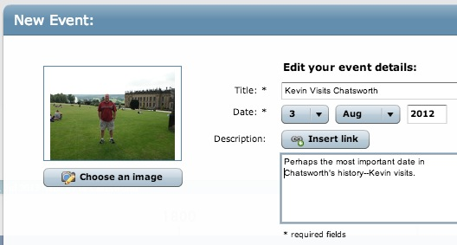

After adding all of your events, click “view this timeline” to see a draft, and then “edit timeline” to return to edit mode. At this point, you are still in draft mode. To publish, click on “change status here” next to “draft.” Move the slider to “public” to publish your timeline.
Click on the title of your timeline to open it up. This is what the public will see when they view your timeline. At the bottom of the page, click the link to “Embed.” | 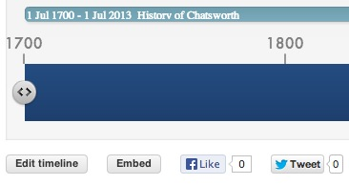
Copy the embed code provided. Change the dimensions of your timeline if you wish, before copying the code. Go to Weebly and drag a Custom HTML block onto your Weebly portfolio page. Paste your embed code into this block, and your timeline will display on your Weebly portfolio. | 