Weebly
Designing and Editing your Page
In the process of building your page you'll be working with:

Elements
Elements are the basic building blocks of your site. All of your site content, be it text, pictures, videos or what have you, is added via an element.

Pages
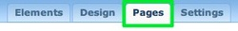
Your site can have as many pages and sub-pages as you want, since there are no page limits for either free or paid accounts. We’ll be adding several pages (including a blog) to our test site in this guide.

Themes / Design
You can select from any one of a number of themes and switch to a different theme at any time. This affects the look of your site. All of your pages and elements remain in place, no matter what theme you choose. We’ll switch themes and take a close look at the theme options (like changing fonts) towards the end of the guide.

Text Elements
Adding an element to a site is as simple as clicking on that element and dragging it to the content area of a page. Let's drag the most basic element -- the paragraph element -- to this sample site.
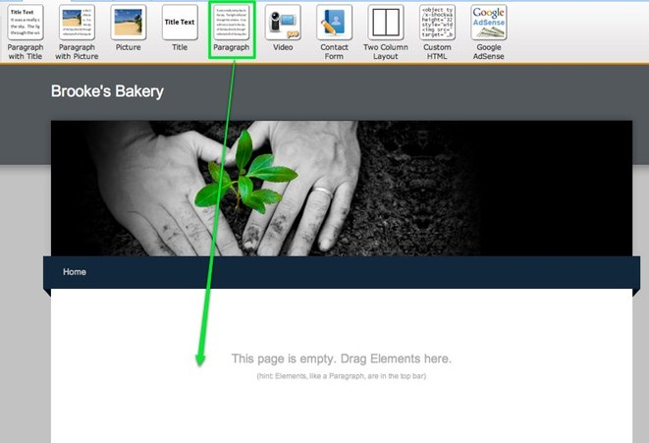
The paragraph element is exactly what it sounds like -- an element for writing text. You can write a word, a sentence or multiple paragraphs in a single element. Just click within the element to start editing.
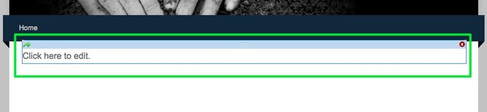
As you write your text, take notice of the blue toolbar at the top of the editor. Every element has its own toolbar with functions specific to that element.
The text toolbar enables you to (from left to right) Bold, Italicize, Underline, change the color, increase the sizeand decrease the size of selected text. You can also create a link (we'll take a closer look at this a bit later) to another site, a page within your own site, an email address or an uploaded file.
Beyond that you can align all the text in an element to the left, center or right, create both bulleted lists and numbered lists, and also undo / redo changes.
One thing you may notice you can't do is change fonts. That's because the font is controlled through the site's theme and not within individual elements. You can change the default font for different areas of your site via the Design tab, and we'll take a closer look at this a bit later in the guide.
Let's add some text to our example site:
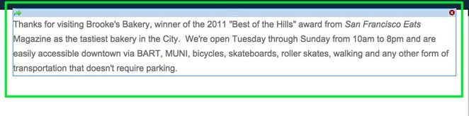To add more text we could keep writing in this same element, add another paragraph element to the page, or use one of the three other text elements:
- Title - Used for adding titles / headers to a page.
- Paragraph w/ Title - A paragraph element with a spot for title already built in.
- Paragraph w/ Picture - A paragraph element with a spot for both a title and an image built in.
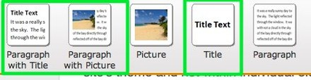
Each of these elements use the same text editing toolbar we looked at above and you can stack as many of them as you want on a page.
Uploading an image to a picture element is as simple as clicking the big blue Sample Image.
This opens a dialog box where you select how you want to upload your image. You can:
- Upload an image from your computer.
- Select one from Flickr's free, searchable library of creative commons licensed images. Using this option will add a small copyright attribution to the footer of your site linking to the photographer who took the image.
- Enter the address of an image from out on the internet. You should only use this third option if you already own the image you're embedding.
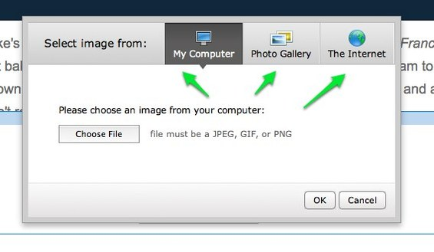

The Edit button appears in the upper left of the image when you roll over it.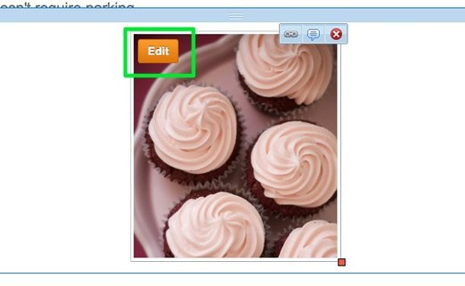
This brings up our ImagePerfect editor. You can use this to crop, rotate and add effects to the image. You can also add more images to this picture element, but this is much more limiting than using our Slideshow or Gallery options.
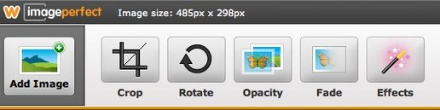
Re-size images by clicking and dragging the box found on the lower-right-corner of each.
Alter Layout
The Two Column Layout Element works like any other element: just drag it to a page. It will stack above or beneath any other elements you've already placed on that page and is quite literally made up of two empty columns separated by a blue bar.
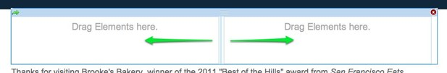
This blue bar can be clicked and dragged to the right or left to increase / decrease the size of a column. Note that this bar does not appear on your published site, so your beautiful content will not be marred by a blue bar running down the middle.
Adding Scribe Notes on the Weebly blog
To create a new post for your blog, use the New Post button at the top of the blog itself.
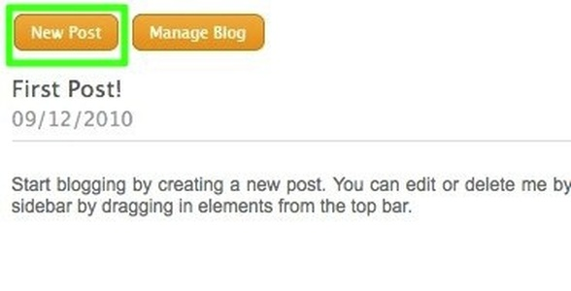
Your blog post has a title and a content area. The title should generally be short - no more than a sentence long or so. The content area includes a basic paragraph element which you can either edit or delete.
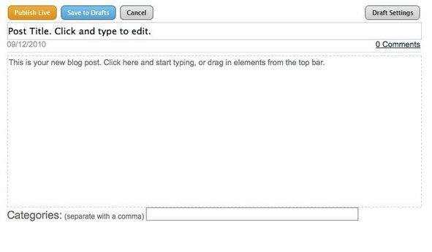
Adding content to a blog post works the same way as adding content to a regular page - just drag elements into the post and edit them to add content.
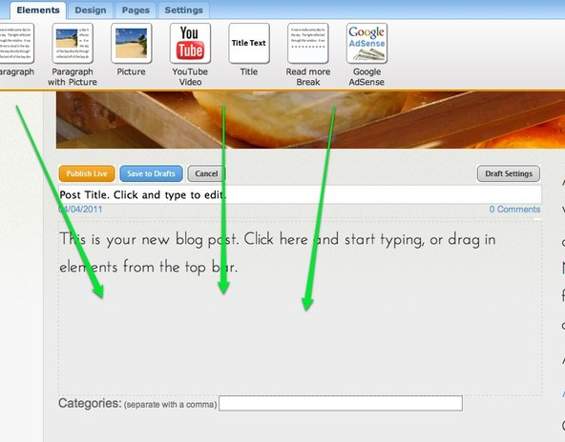

After adding content, you can Publish the post to your live site (which will make it instantly available) or Save to Drafts to edit / publish it later.

